**Unit 2 – Worksheet 2**

**Distance vs. Displacement**

Adapted from AMTA 2006

**Part I**

An overhead view of the paths that Dorothy and Toto take along the yellow brick road is shown below.

From start to finish, who travels farther? Justify your answer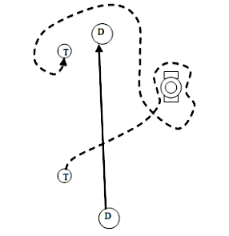.

Find a classmate with a different answer. Why did they choose this answer?

New Terms and Definitions:

More examples using the new terms:

**Part II**

**Using Number Lines to Measure Position and Finding Change in Position**

On each number line, you will see two cars: an initial car (dashed) and a final car (solid).

* Record the positions of each car.
* Write a mathematical expression for calculating the change in position of the car
* Record the change in position of the car.
* Measurements are in meters (m)

Example:

-10

0

-5

5

10

Initial Position = 0 m

Final Position = 6 m

Mathematical Expression: $x_{f}-x_{o }$ = 6 m - 0 m

Change in Position = 6 m

1.

-10

0

-5

5

10

Initial Position =

Final Position =

Mathematical Expression:

Change in Position =

2.

-10

0

-5

5

10

Initial Position =

Final Position =

Mathematical Expression:

Change in Position =3.

-10

0

-5

5

10

Initial Position =

Final Position =

Mathematical Expression:

Change in Position =

-10

0

-5

5

10

4.

Initial Position =

Final Position =

Mathematical Expression:

Change in Position =

-10

0

-5

5

10

5.

Initial Position =

Final Position =

Mathematical Expression:

Change in Position =

-10

0

-5

5

10

6.

Initial Position =

Final Position =

Mathematical Expression:

Change in Position =

7.

-10

0

-5

5

10

Initial Position =

Final Position =

Mathematical Expression:

Change in Position =

8.

-10

0

-5

5

10

Initial Position =

Final Position =

Mathematical Expression:

Change in Position =

These last two cars make a turn at position 2. Find the change in position from 1 to 3 and how far the car travelled in all from 1 to 2 to 3.

3

2

-10

0

-5

5

10

1

9.

3

1

2

-10

0

-5

5

10

10.

**Part III**

**Translating Between Representations**

Given the representation present in each of the following scenarios, provide the missing representations.

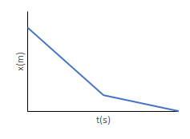

Verbal representation:

|  |  |
| --- | --- |
|  |  |

Verbal representation:

|  |  |
| --- | --- |
|  |  |

|  |  |
| --- | --- |
|  |  |
| Verbal representation: |  |

|  |  |
| --- | --- |
|  |  |

Verbal representation:

1. Create your own scenario and determine the position-time graph and motion map to match this.

